IV. Biographies of Panelists
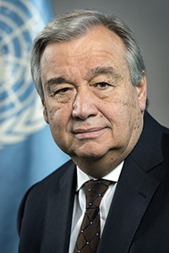
António Guterres, the ninth Secretary-General of the United Nations, took office on 1st January 2017.
Prior to his appointment as Secretary-General, Mr. Guterres served as United Nations High Commissioner for Refugees from June 2005 to December 2015, heading one of the world’s foremost humanitarian organizations during some of the most serious displacement crises in decades. The conflicts in Syria and Iraq, and the crises in South Sudan, the Central African Republic and Yemen, led to a huge rise in UNHCR’s activities as the number of people displaced by conflict and persecution rose from 38 million in 2005 to over 60 million in 2015.
Before joining UNHCR, Mr. Guterres spent more than 20 years in government and public service. He served as prime minister of Portugal from 1995 to 2002, during which time he was heavily involved in the international effort to resolve the crisis in East Timor.
As president of the European Council in early 2000, he led the adoption of the Lisbon Agenda for growth and jobs and co-chaired the first European Union-Africa summit. He was a member of the Portuguese Council of State from 1991 to 2002.
Mr. Guterres was elected to the Portuguese Parliament in 1976 where he served as a member for 17 years. During that time, he chaired the Parliamentary Committee for Economy, Finance and Planning, and later the Parliamentary Committee for Territorial Administration, Municipalities and Environment. He was also leader of his party’s parliamentary group.
From 1981 to 1983, Mr. Guterres was a member of the Parliamentary Assembly of the Council of Europe, where he chaired the Committee on Demography, Migration and Refugees.
For many years Mr. Guterres was active in the Socialist International, a worldwide organization of social democratic political parties. He was the group’s vice-president from 1992 to 1999, co-chairing the African Committee and later the Development Committee. He served as President from 1999 until mid-2005. In addition, he founded the Portuguese Refugee Council as well as the Portuguese Consumers Association DECO and served as president of the Centro de Acção Social Universitário, an association carrying out social development projects in poor neighbourhoods of Lisbon, in the early 1970s.
Mr. Guterres is a member of the Club of Madrid, a leadership alliance of democratic former presidents and prime ministers from around the world.
Mr. Guterres was born in Lisbon in 1949 and graduated from the Instituto Superior Técnico with a degree in engineering. He is fluent in Portuguese, English, French and Spanish. He is married to Catarina de Almeida Vaz Pinto, Deputy Mayor for Culture of Lisbon, and has two children, a stepson and three grandchildren.

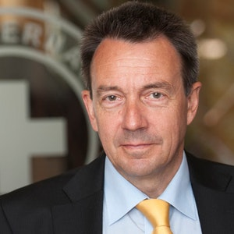
Peter Maurer is the President of the International Committee of the Red Cross (ICRC), since July 2012. Mr. Maurer's priorities for his presidency include strengthening humanitarian diplomacy, engaging States and other actors for the respect of international humanitarian law and improving the humanitarian response through innovation and new partnerships. He has led the organization through a historic budget increase to meet the growing needs of victims of armed conflict, from 1.1 bn CHF in 2011 to over 1.6 bn CHF in 2015. In 2004, Mr. Maurer was appointed ambassador and permanent representative of Switzerland to the United Nations in New York. In this position, he worked to integrate Switzerland, which had only recently joined the United Nations, into multilateral networks. In June 2009, the UN General Assembly elected Mr. Maurer chairman of the Fifth Committee, in charge of administrative and budgetary affairs. In addition, he was elected chairman of the Burundi configuration of the UN Peacebuilding Commission. In January 2010, he was appointed secretary of State for foreign affairs in Bern.

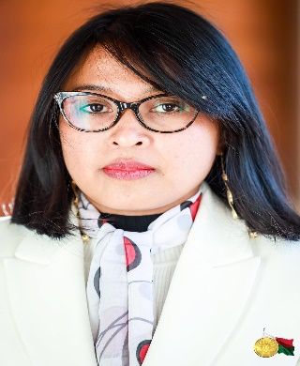
Mrs. Rindra Hasimbelo Rabarinirinarison
Minister of Economy and Finance of Madagascar.
Mrs. Rabarinirinarison is an expert in public procurement and international relations. Her areas of expertise include public management, public finance, the judiciary, and international negotiations. Prior to her nomination as Minister of Economy and Finance in August 2021, she ensured the follow-up of the General Policy of the State, in terms of economic, fiscal, budgetary, and financial management. She was responsible for coordinating the partnership framework with technical and financial partners as well as conducting international negotiations in her capacity as Secretary General of the Ministry of Finance. Working for the National Commission for Public Procurement for nearly ten years, she coordinated and administered the work of the Commission as its National President since 2016. A lawyer and political scientist by training, she also holds a degree in Public Management from Georgia State University in Atlanta and in international public procurement from the International Law Institute in Washington DC. She graduated from the National School for Magistrates and holds a Master’s degree in public law and political sciences, with emphasis on international relations, awarded jointly by the Catholic University of Madagascar and the University of Reunion.

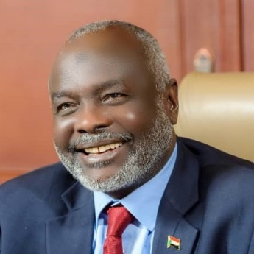
Dr. Gibril Ibrahim is the Minister of Finance and Economic Planning of the Republic of the Sudan. Dr Gibril joined the Transitional Civilian Government of Sudan after the signing of the Juba Peace Agreement. Prior to becoming minister Dr Gibril was the leader of the Justice and Equality Movement, one of Sudan’s most prominent political parties, which had mounted a resilient armed movement against the previous regime for many decades. Dr Gibril holds a masters degree and a PhD in Economics, which he obtained from Meiji University in Japan. He is determined to use his time as finance minister to oversee the transformation of the Sudanese economy, ensuring the implementation of a balanced economic policy, that is pro-poor whilst being supportive of investment and the private sector and seeing Sudan through the HIPC initiative process.

