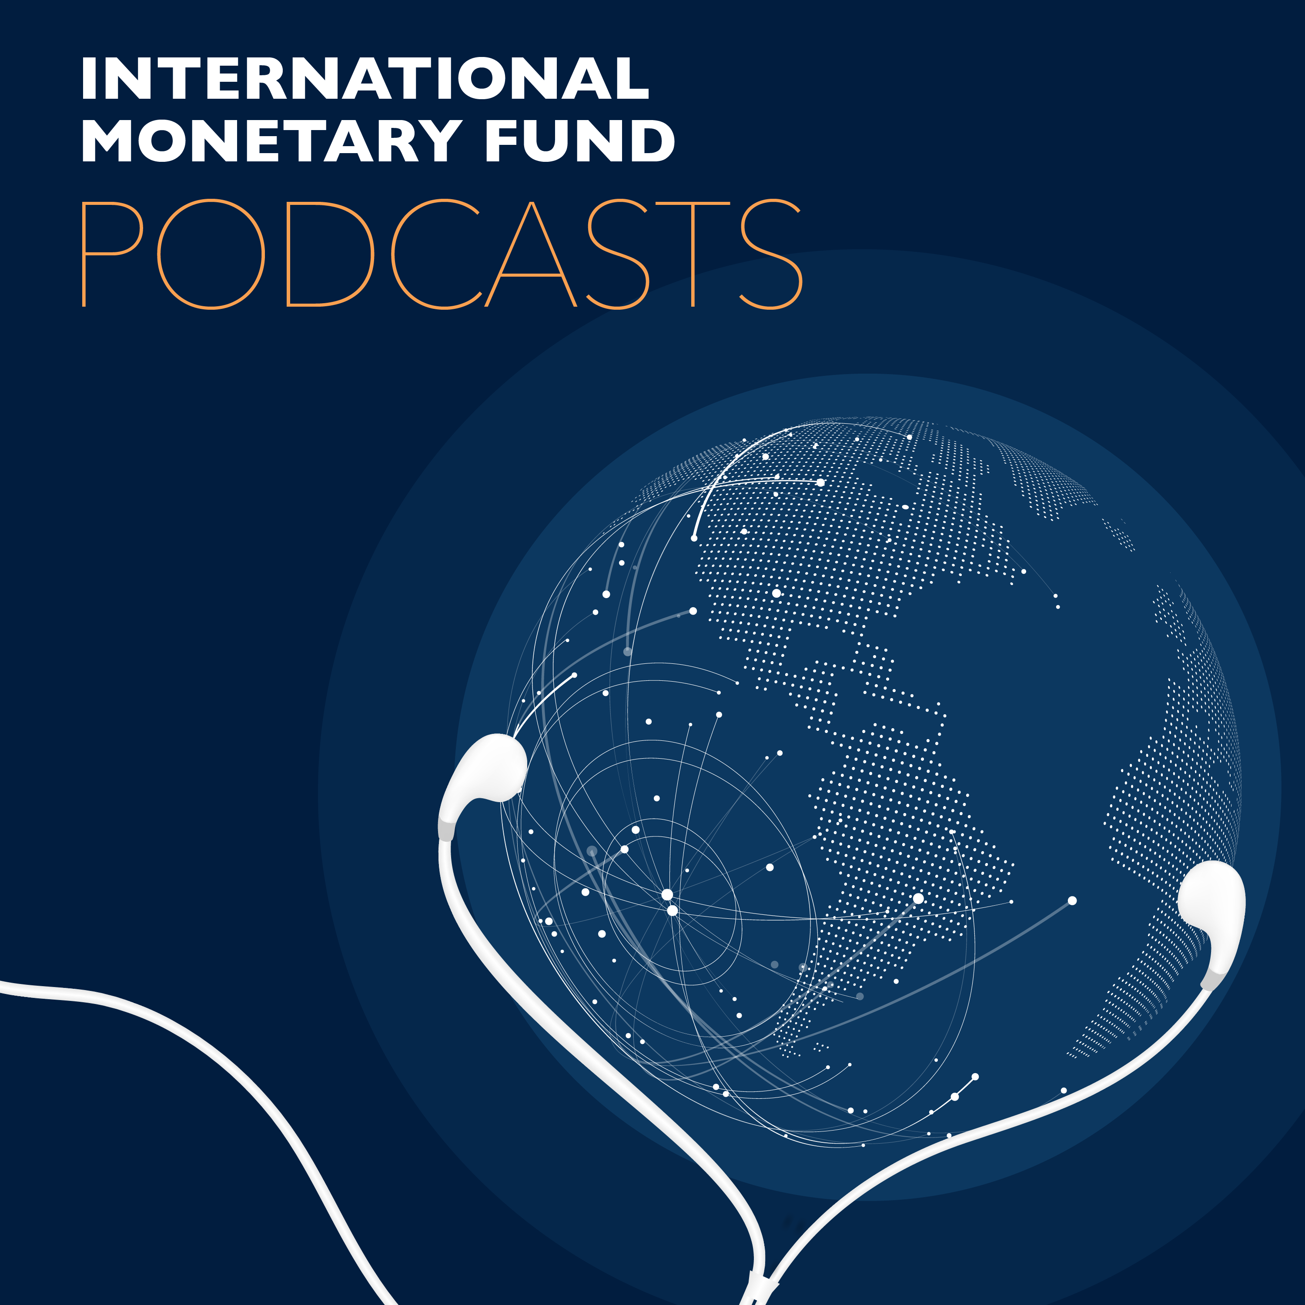
Transcript of IMF podcast:
Kristalina Georgieva on Human, Economic Costs of Covid-19
Kristalina Georgieva:
We will massively step up emergency finance. Nearly 80 countries are requesting our help.
Bruce Edwards:
In this program, IMF managing director Kristalina Georgieva on the profound economic impact worldwide of the coronavirus.
Kristalina Georgieva:
We have already seen investors pulling $83 billion from emerging markets since the beginning of the crisis. The largest capital outflow ever recorded.
Bruce Edwards:
Welcome to this podcast produced by the International Monetary Fund. I'm Bruce Edwards. We're going to deviate somewhat from the usual interview format today to bring you Kristalina Georgieva's statement following her call with G20 finance ministers and central bank governors from around the world where they discussed the extraordinary circumstances of the current health crisis and the extraordinary measures it will take to mitigate its economic impact.
Kristalina Georgieva:
The human costs of the coronavirus pandemic are already immeasurable and all countries need to work together to protect people and limit the damage on the economies. This is a moment for solidarity, which was a major theme of the meeting today of the G20 finance ministers and central bank governors. There I emphasized three points. First, the outlook for global growth. For 2020 it is negative, a recession at least as bad as during the global financial crisis or worse, but we expect recovery in 2021. To get to it, it is paramount to prioritize containment and strengthen health systems everywhere. The economic impact is and will be severe, but the faster the virus stops, the quicker and stronger the recovery will be. We at the IMF strongly support the extra ordinary fiscal actions many countries have already taken to boost health systems and protect affected workers and firms.
Kristalina Georgieva:
We welcome the moves of major central banks to ease monetary policy. These are bold efforts and they are not only in the interest of each individual country, but of the global economy as a whole. Even more will be needed, especially on the fiscal front. My second point is that advanced economies are generally in a better position to respond to the crisis, but many emerging markets and low income countries face significant challenges. They are badly affected by outward capital flows and domestic activity will be severely impacted as countries respond to the epidemic. We have already seen investors pulling $83 billion from emerging markets since the beginning of the crisis, the largest capital outflow ever recorded. We are particularly concerned about low income countries in debt distress. It is an issue in which we are working very closely with the world bank. Third, what can we, the IMF do to support our members?
Kristalina Georgieva:
We are concentrating bilateral and multilateral surveillance on this crisis and we are providing policy advice on actions to temper its impact. We will massively step up emergency finance. Nearly 80 countries are requesting our help and we are working closely with other international financial institutions to provide a strong coordinated response so we can be more impactful together. We are replenishing the Catastrophe Containment and Relief Trust to help the poorest countries. We welcome the pledges already made and we call on others to join. We stand ready to deploy all our $1 trillion U.S. dollars lending capacity and we are looking to other available options.
Kristalina Georgieva:
Several low and middle income countries have asked the IMF to make an SDR allocation, special drawing rights allocation as we did during the global financial crisis. We are exploring this option with our membership. Also, major central banks have initiated bilateral swap lines with emerging market countries. As the global liquidity crunch takes hold, we need members to provide additional swap lines. Again, we will be exploring with our executive board and membership a possible proposal that would help facilitate a broader network of swap lines, including through an IMF swap-type facility. Let me finish with the following. These are extra ordinary circumstances. Many countries are already taking unprecedented measures. We at the IMF working with all our member countries will do the same. Let us stand together through this emergency to support all people across the world. Together we can get through it.
Bruce Edwards:
That was IMF managing director Kristalina Georgieva describing the profound economic impact the coronavirus pandemic is having on economies around the world. Go to imf.org to find out more about how the IMF and its global partners are responding to the crisis. Look for other IMF podcasts wherever you get your podcasts, subscribe if you like what you're hearing and follow us on Twitter @IMF_podcast. Thanks for listening.

